Ulvi Bajarani

SID 20539914

CSCI 6345 – Advanced Computer Networks

Summer II

Assignment 5

Creating the Domain Controller, DHCP, DNS in Windows Server 2019 and joining to the Domain by Windows 8.1 Professional user.

After setting the Static IP (It is important to mention that the phone used due to the fact that UTRGV doesn’t allow DHCP Server) and turning off the firewall, it is important to allow all remote connections by allowing Remote Desktop. It is done by changing Remote Desktop option either by PowerShell or from Server Manager (as provided below) by clicking Disabled, then setting the settings as provided below (in the screenshot, it is done separately during the installation, which is also possible.):

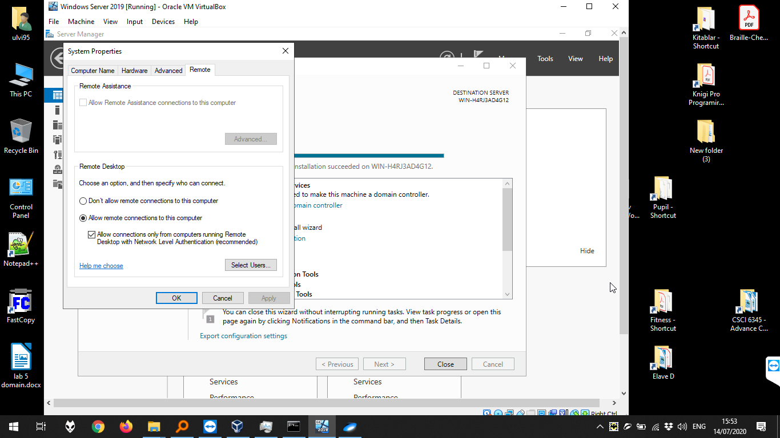

Now, let’s start to set the domain by Manage > Add Roles and Features. In the screenshot below, the option “Role-based or feature-based installation” is chosen:

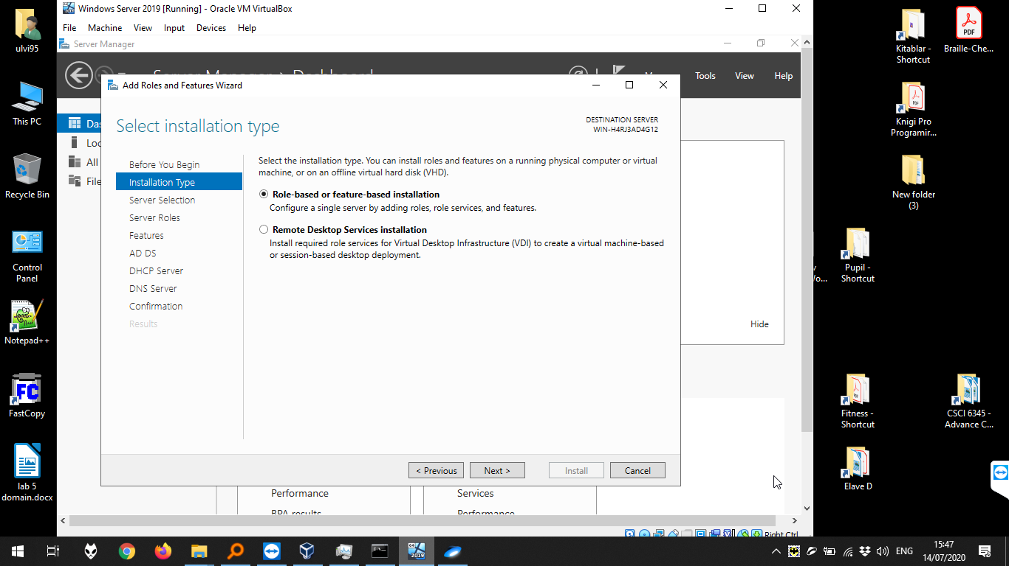

Then, we choose the server:

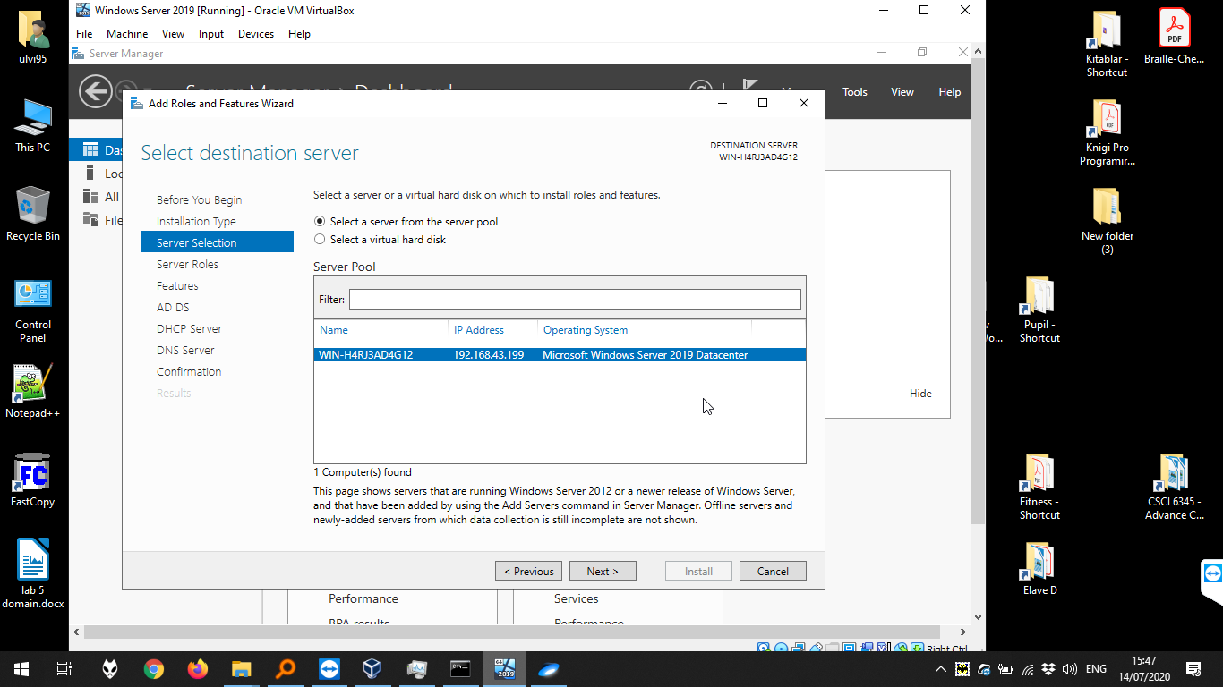

The choosing Server Roles. We keep other options as in the default, adding “Active Directory Domain Services”, “DHCP Server”, “DNS Server”:

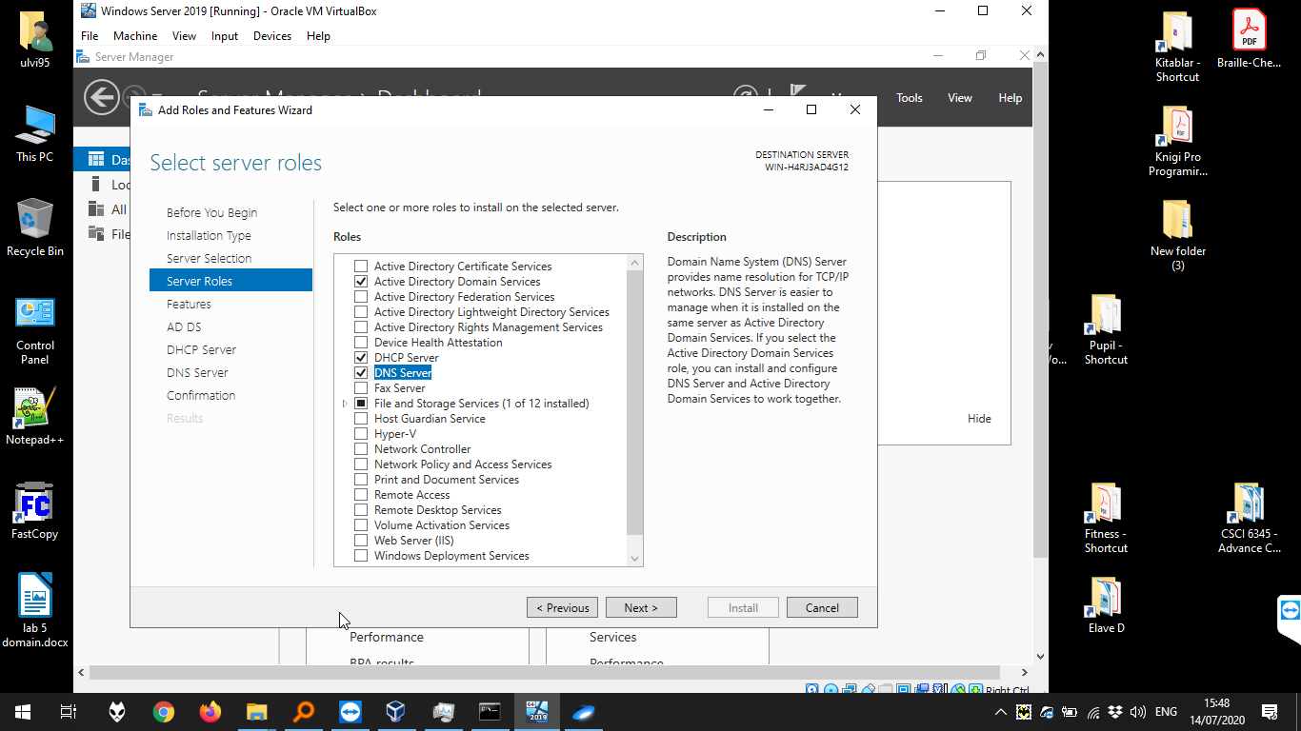

We tick the “Next” button and press “Install” in the final.

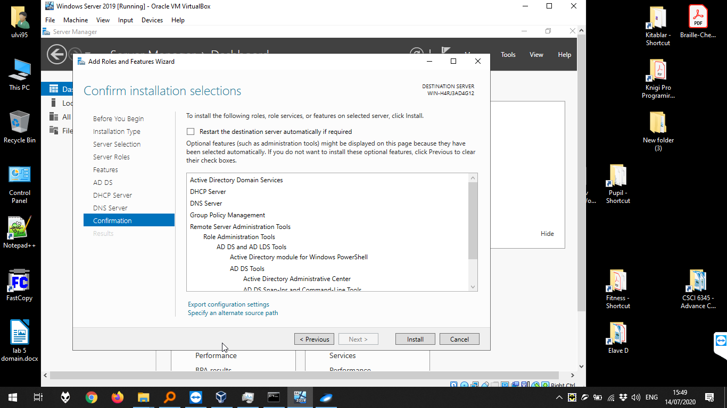

Then, we should finalize the Active Directory Options in Deployment Configuration. We create a new forest, ending with **.local** in the name:

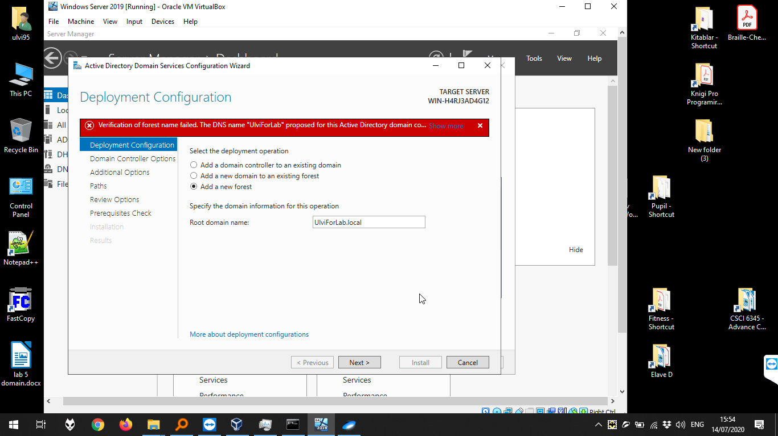

Then, we set all passwords of our account, and tick till the “Prerequisites Check”:

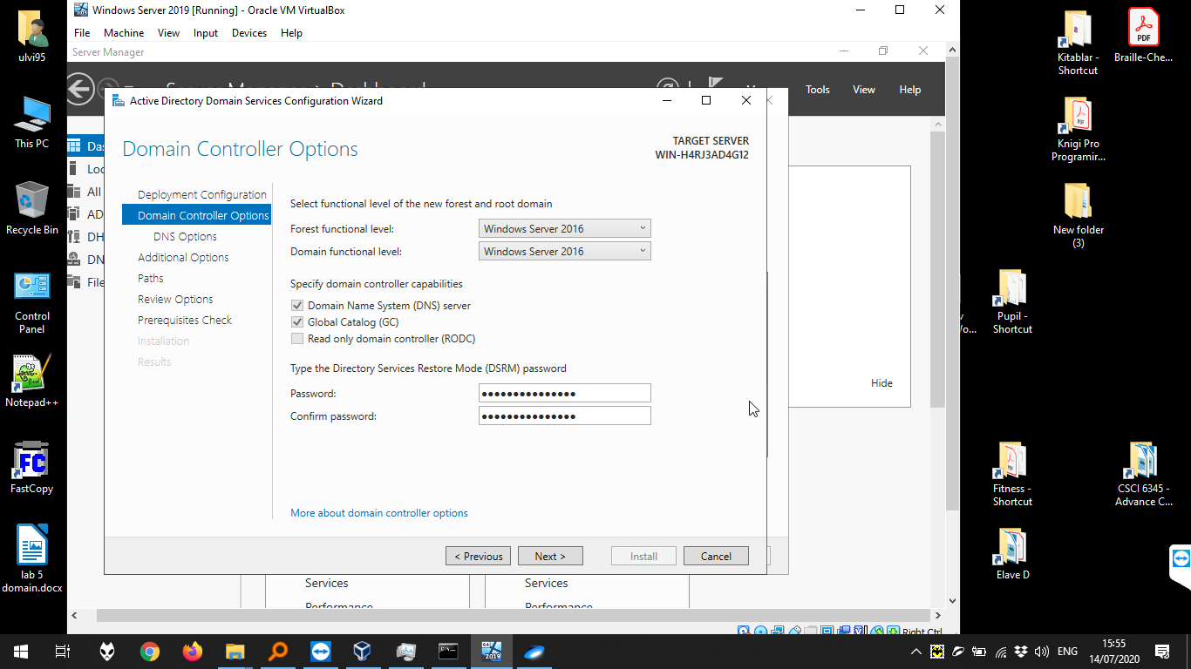

All prerequisites are OK, we can press “Install”

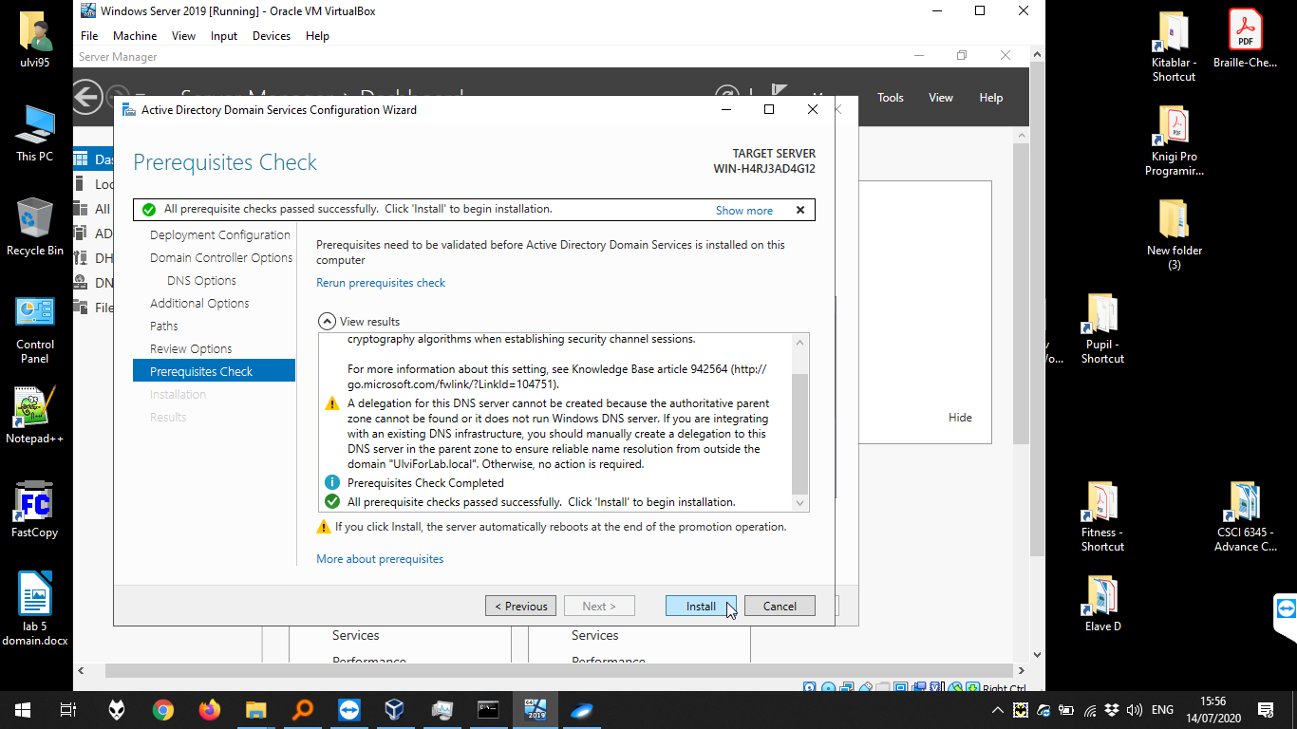

After restart, we have the domain UlviForLab:

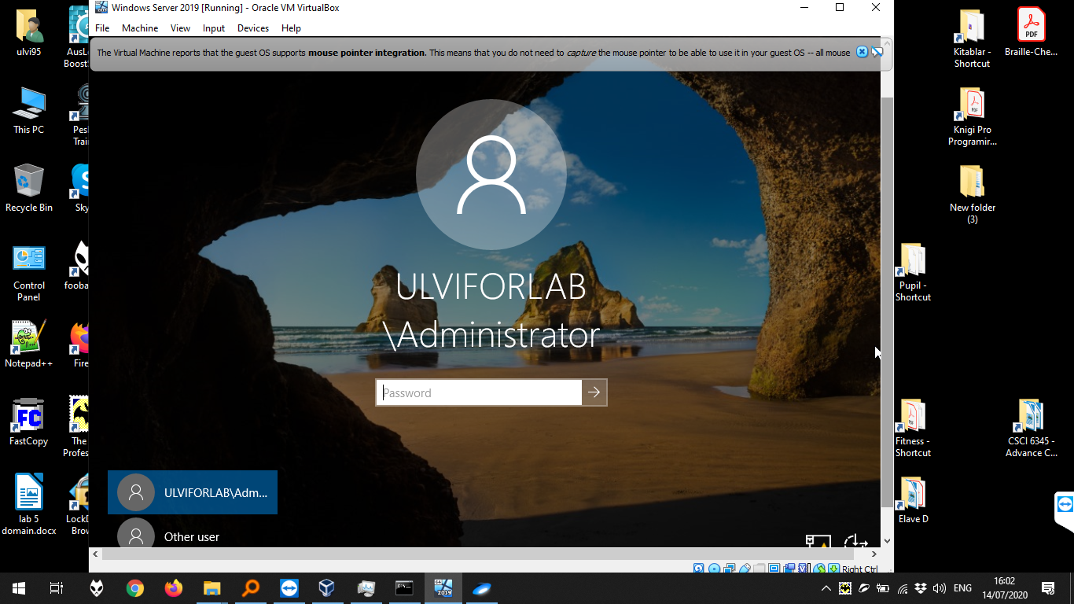

Let’s complete DHCP Configuration:

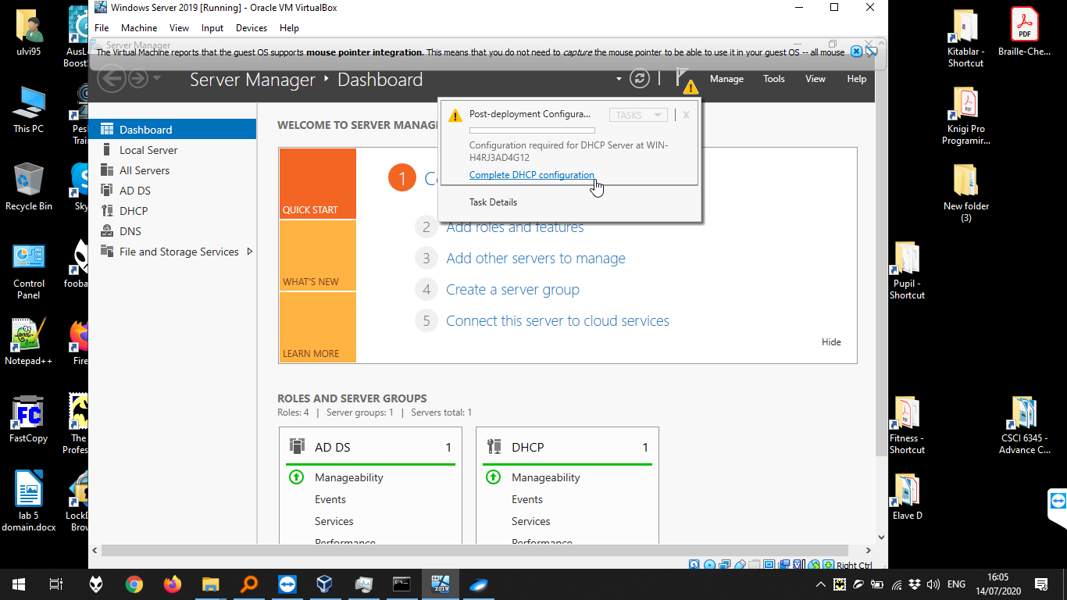

We keep all default:

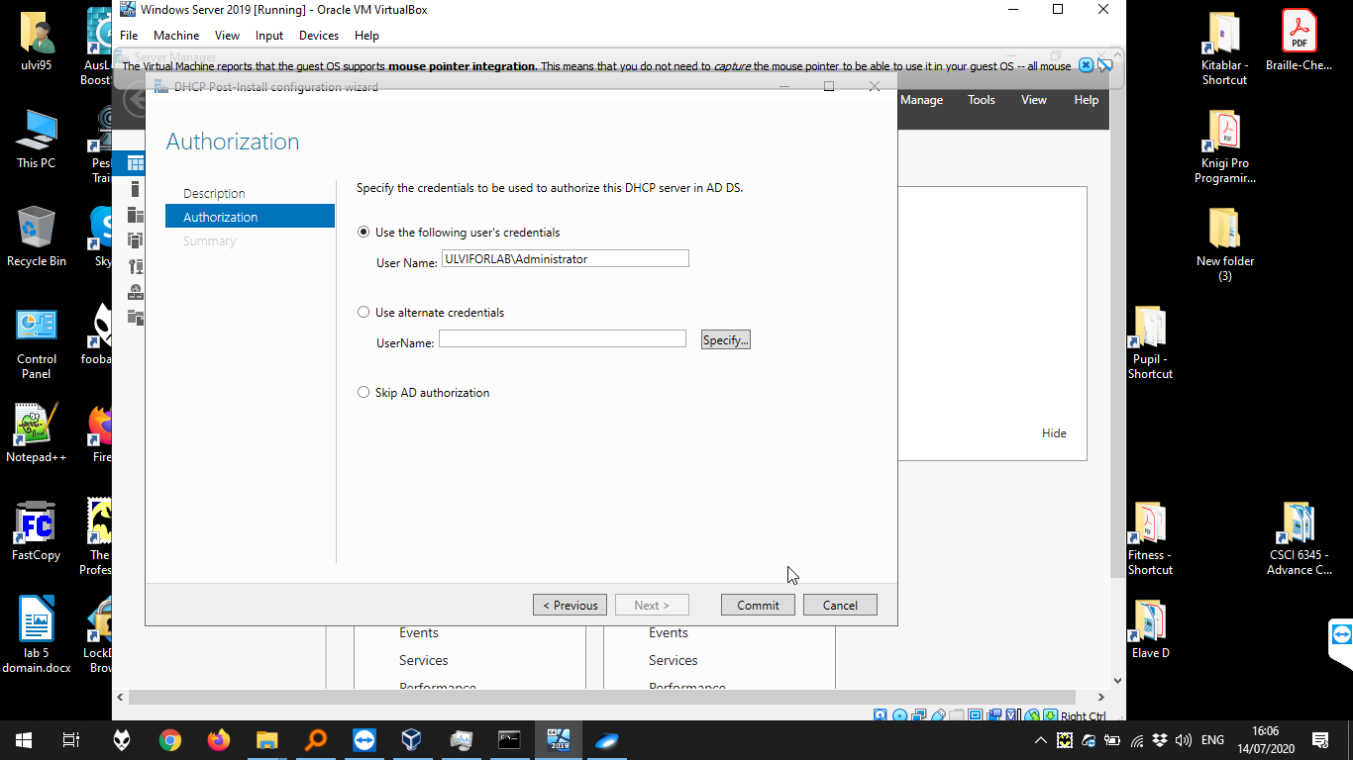

Then, we go to Manage > DHCP:

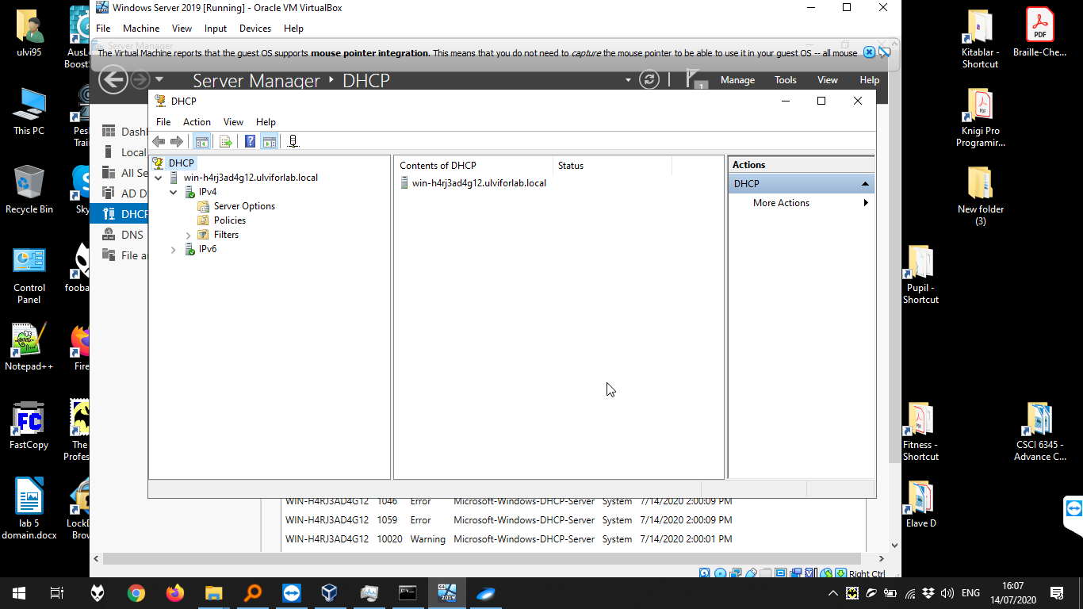

In DHCP Window, we create a new scope for IPv4:

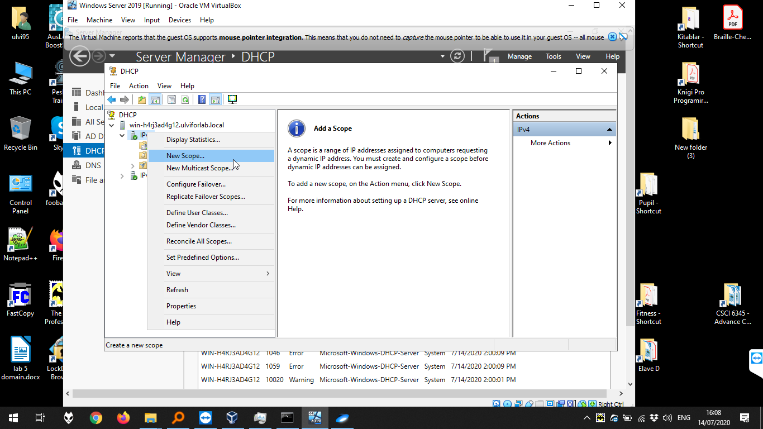

In the window, we define the name:

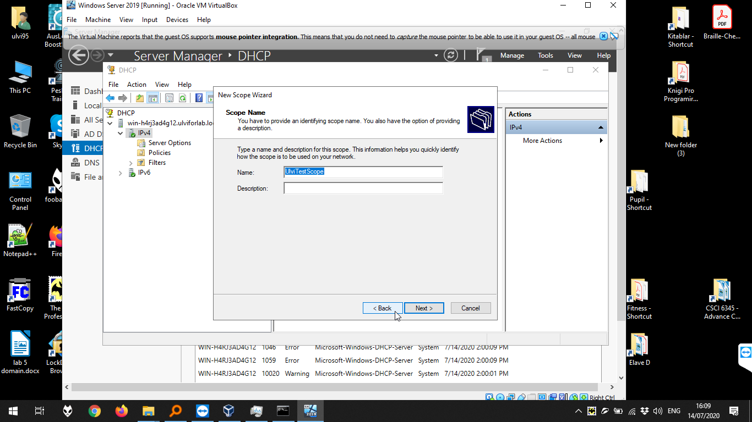

Then, we define the scope. Our scope is between 200 and 210.

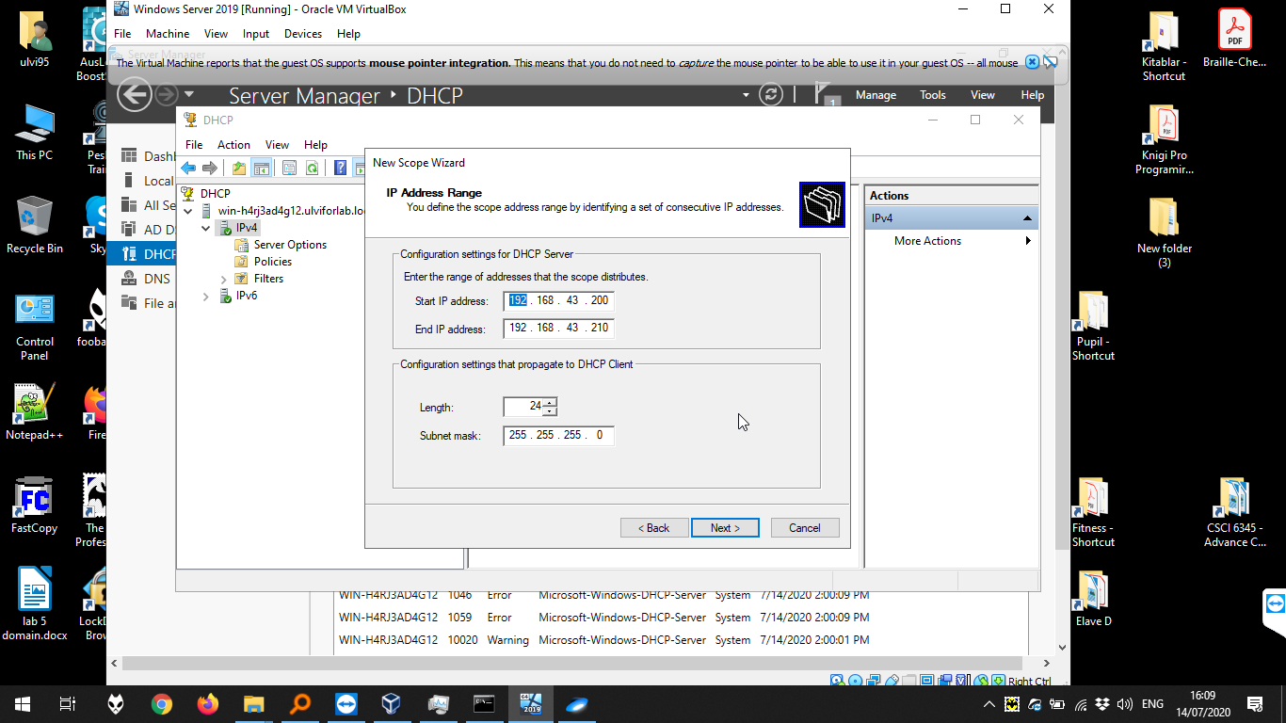

We configure the options immediately:

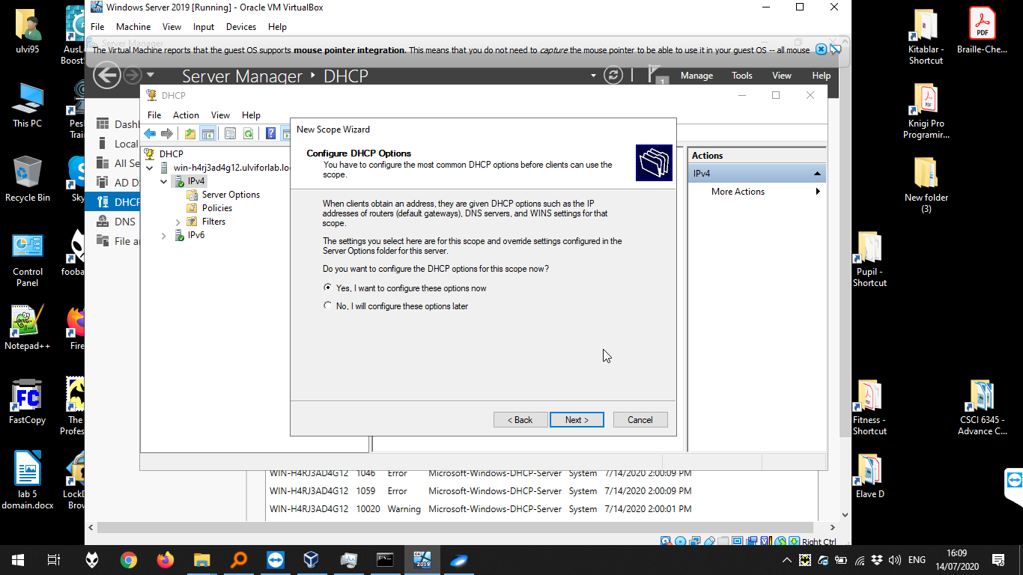

Then, we add the Default Gateway in the list of Default Gateway and press “Next”:

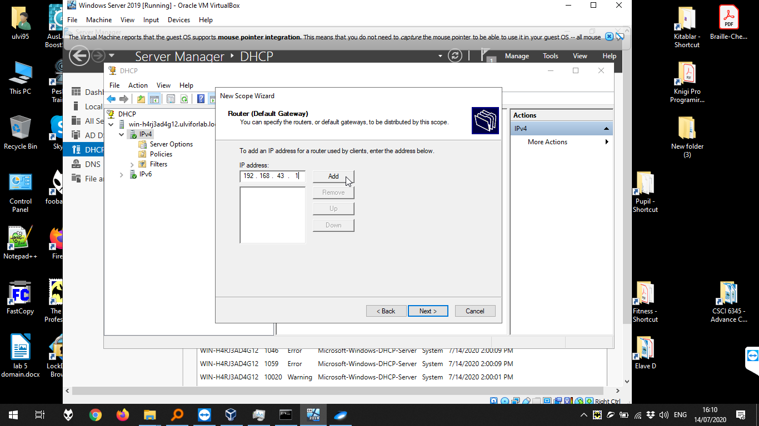

Then, we press “Next”:

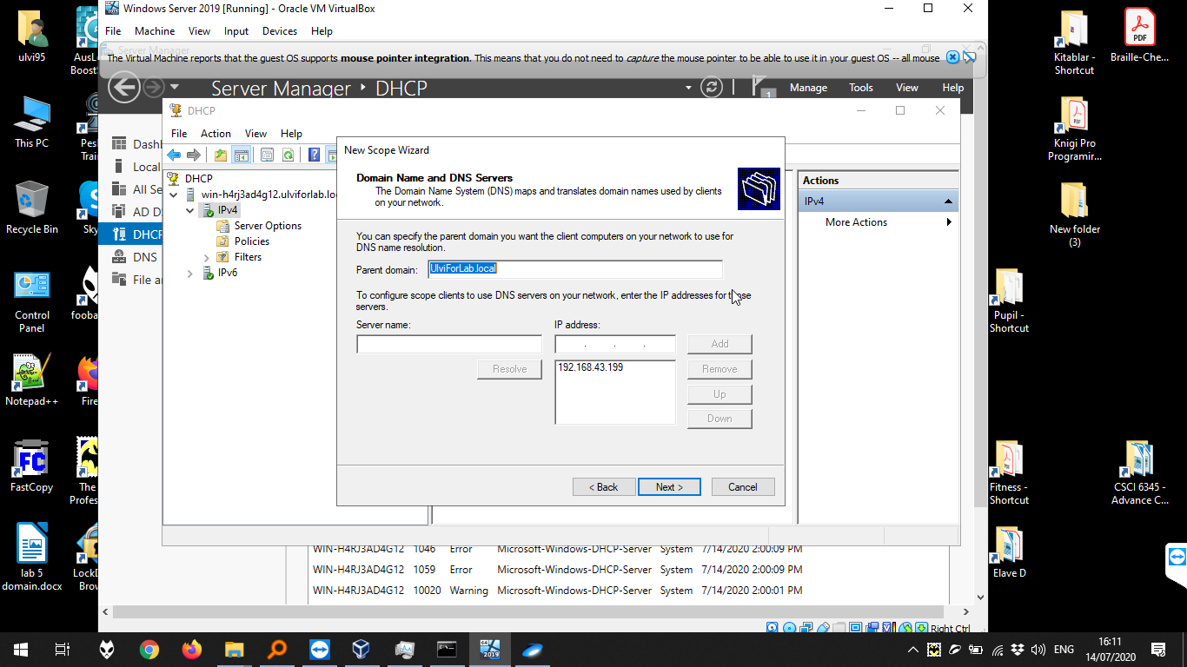

We activate the scope now:

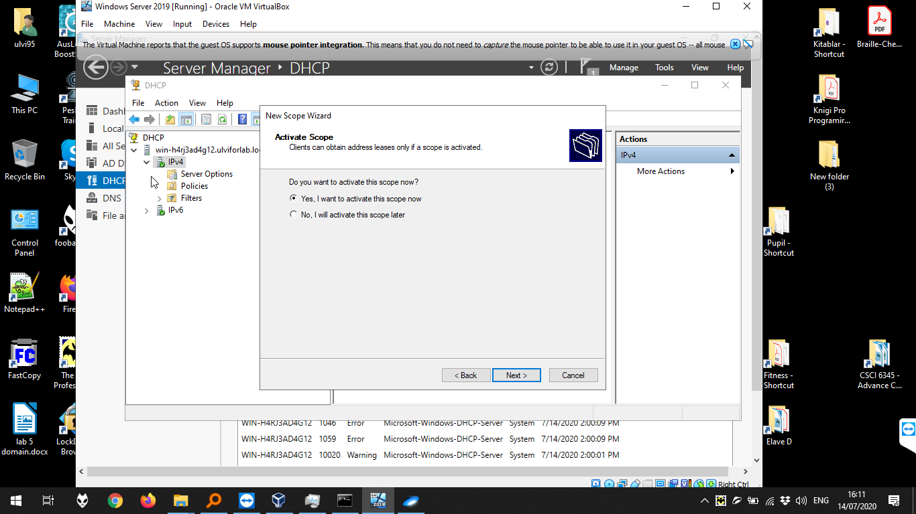

We can see our scope now:

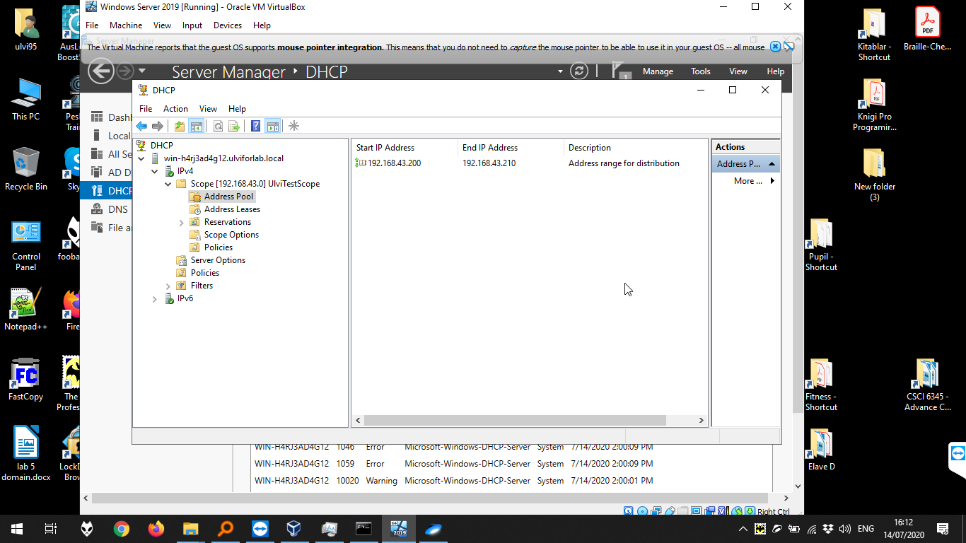

To avoid the problems, we can add the user by Manage > Active Directory Users and Computers, then the name of our domain > New > User:

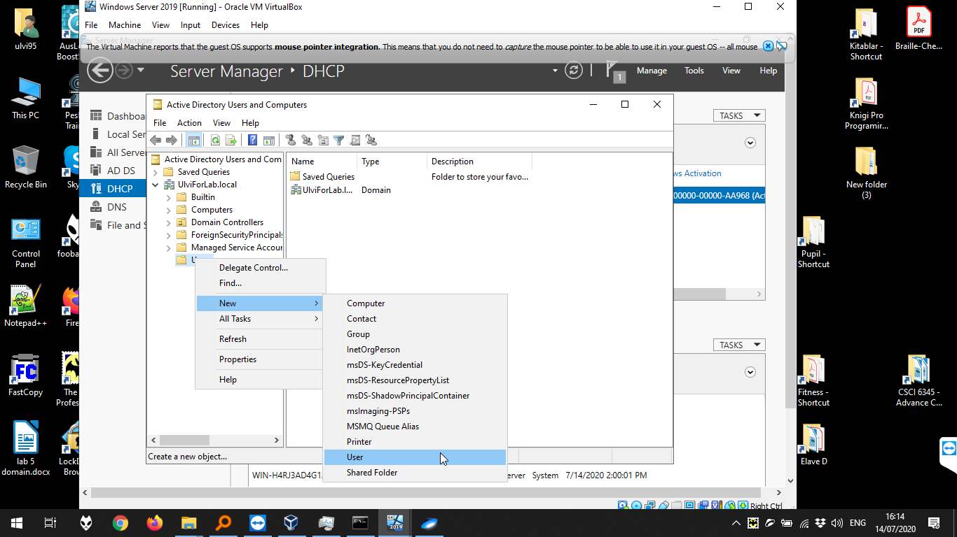

We define the user Full name and logon name:

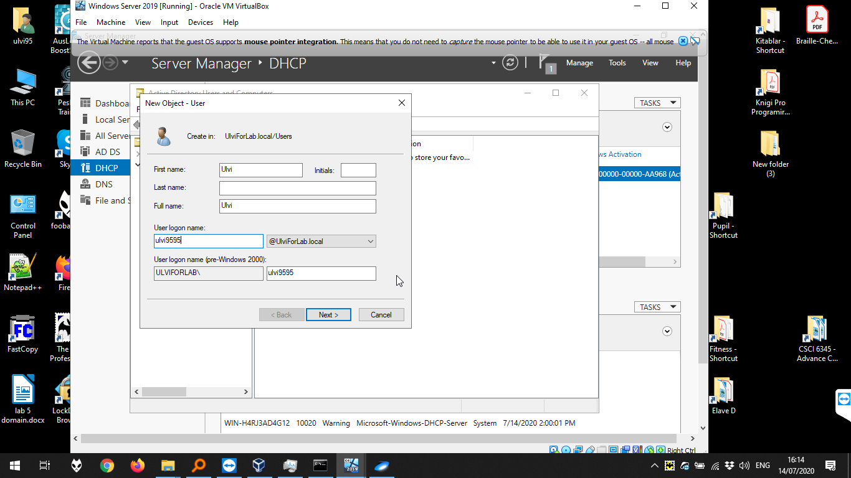

Then, we define the password:

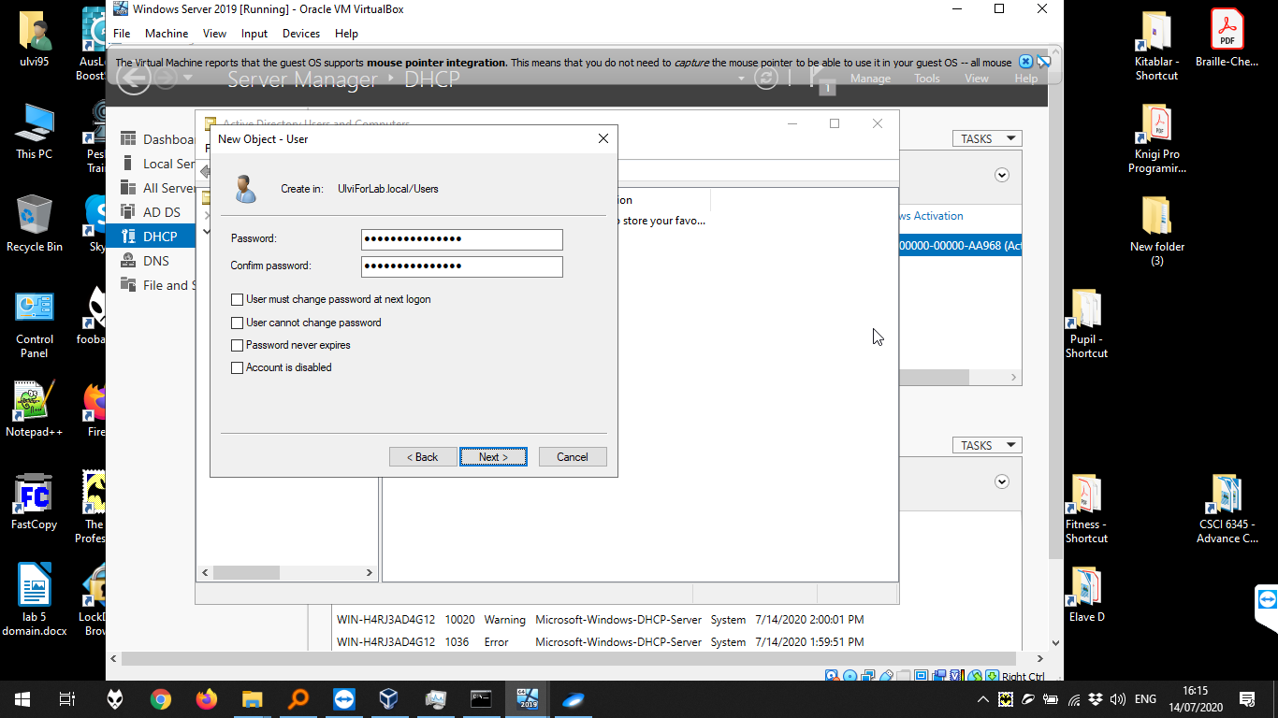

Now, let’s set the DNS. It is done by Manage > DNS > Reverse Lookup Zones > New Zone:

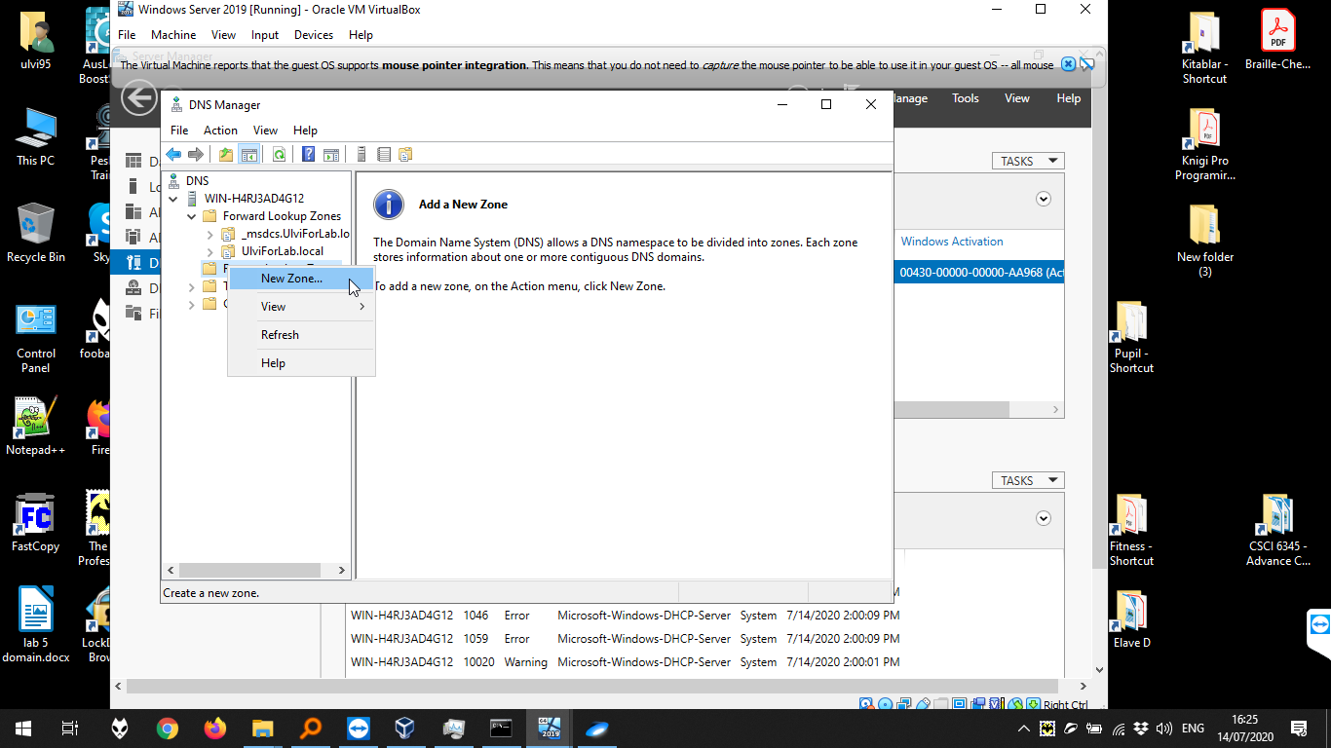

We choose “Primary Zone” and click next:

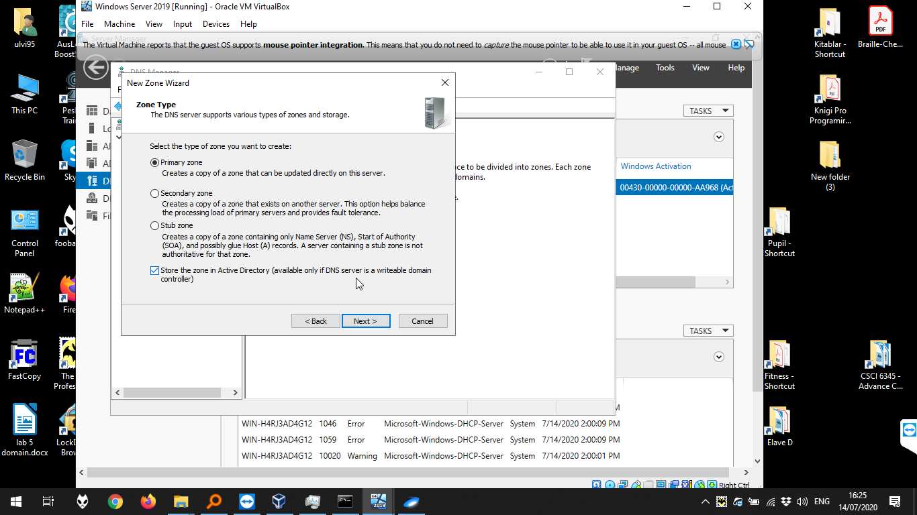

We choose DNS for the domain:

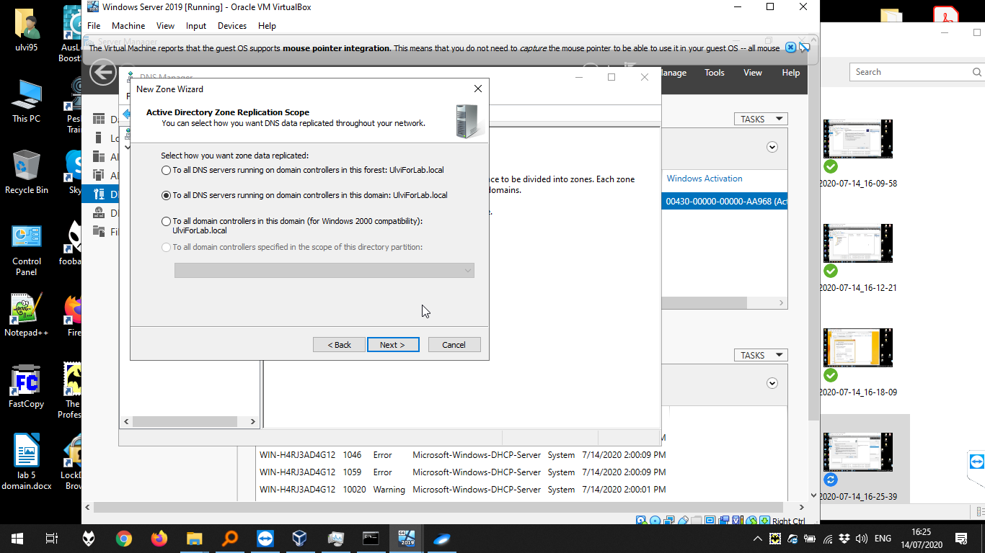

We choose IPv4:

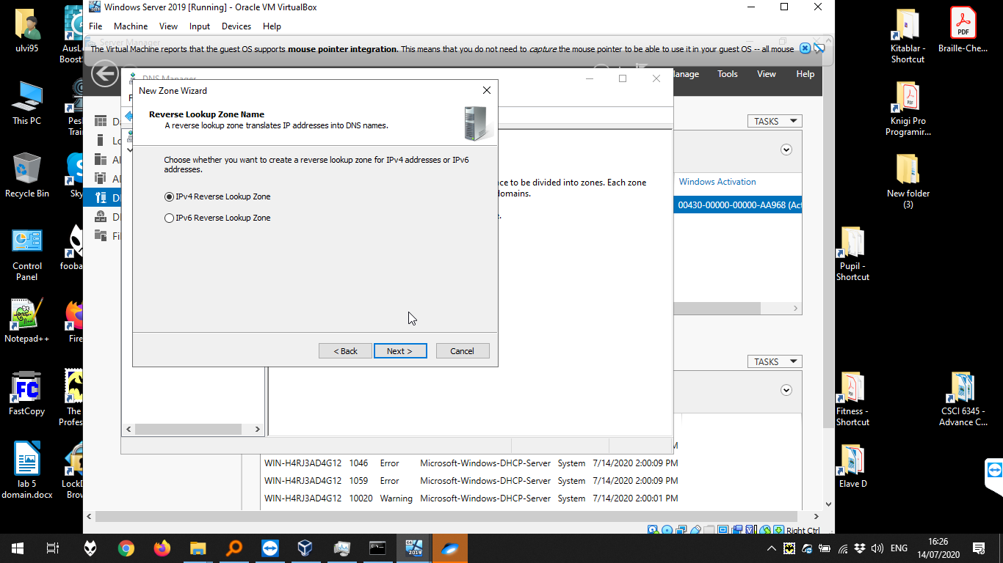

Then, we write first three octets of our IP:

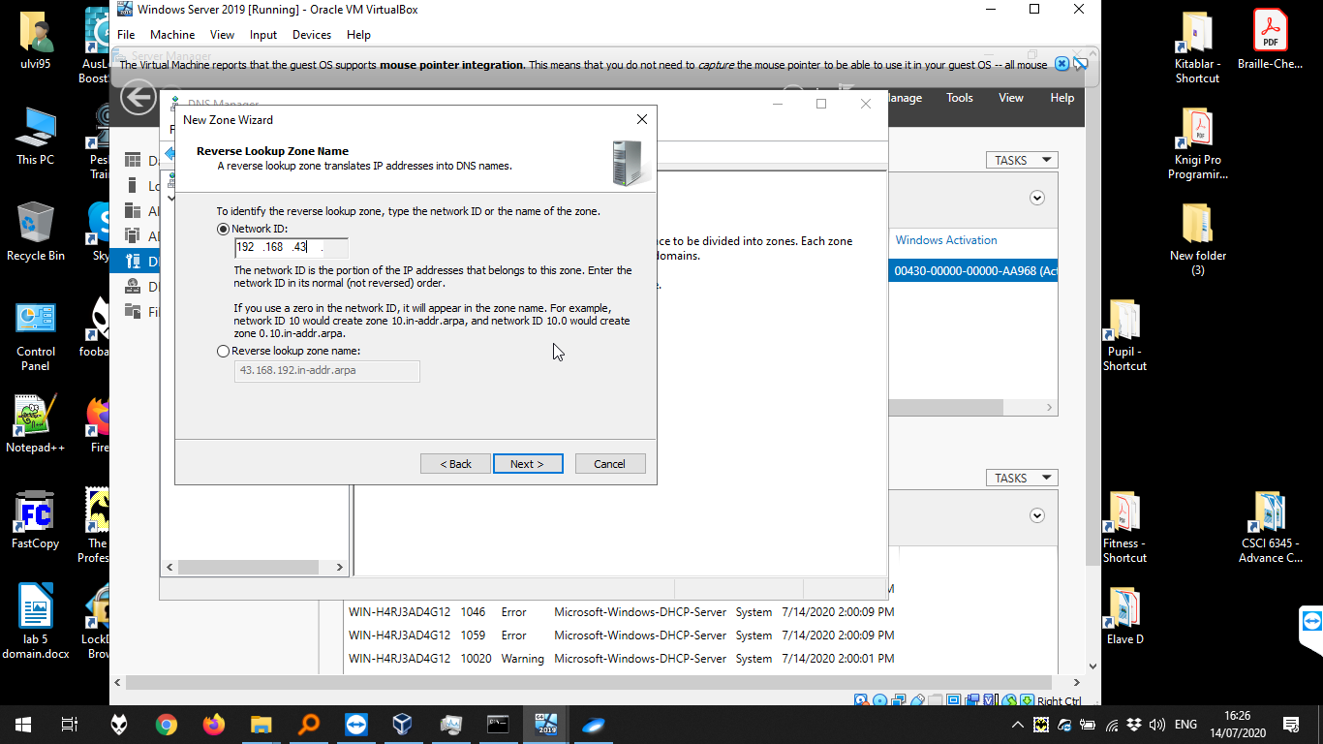

We keep the option as below:

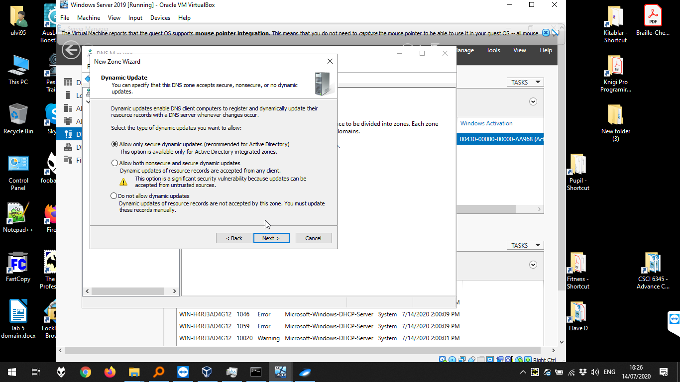

Then, we create the pointer for the zone:

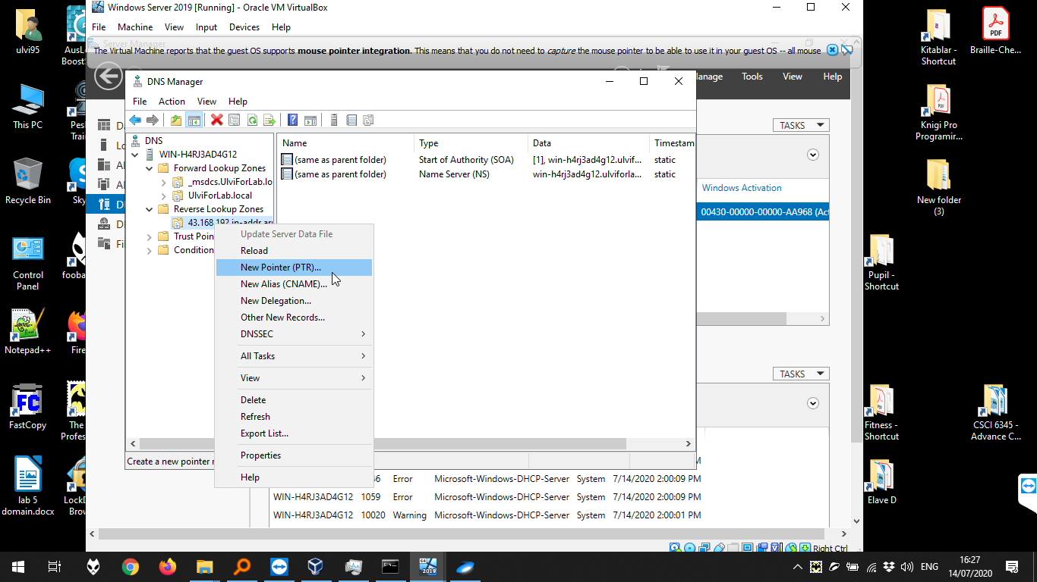

Then, we choose the host record of our computer:

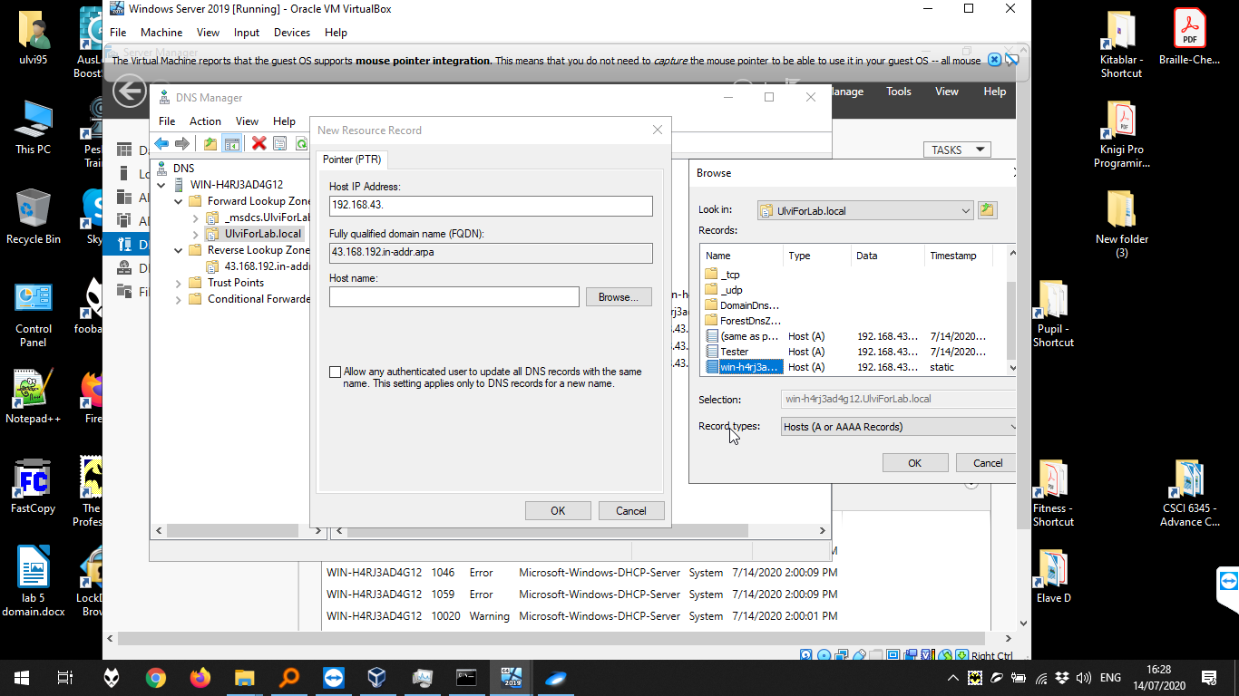

Now, we can see the DNS:

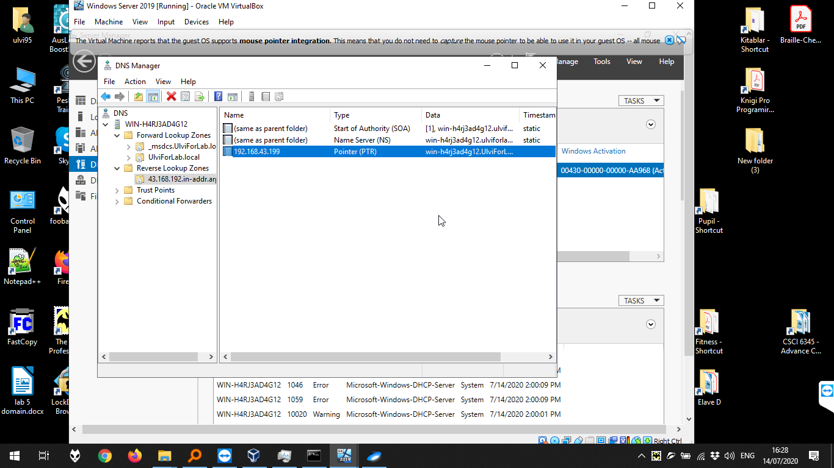

Now, let’s try to connect to the domain with Windows 8.1 Professional. First, we add our DNS Server to the IPv4 Ethernet Options:

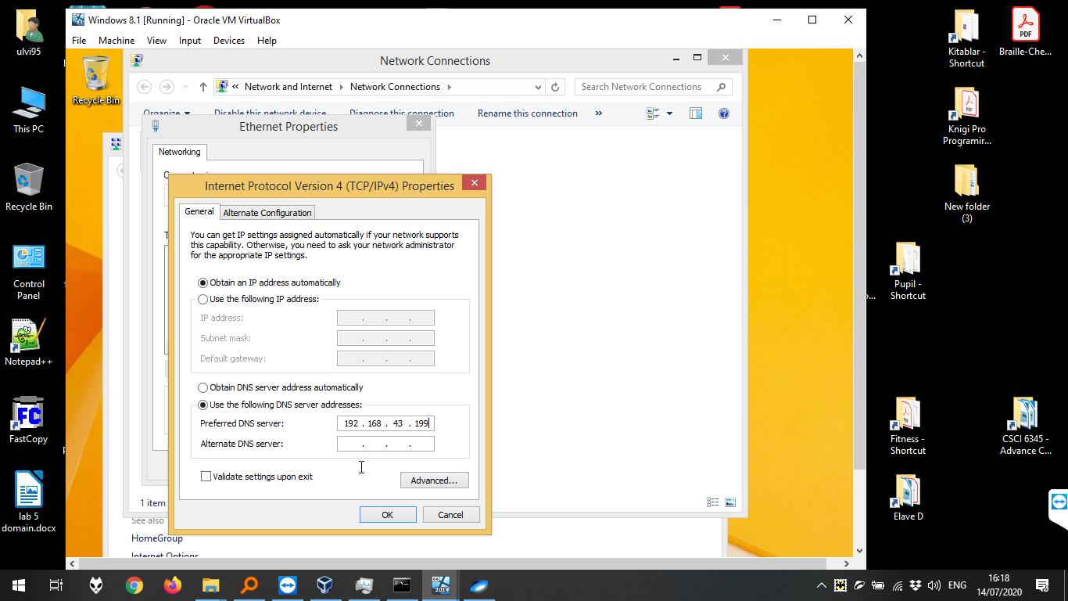

Then, we enter to This PC > System. There, we press “change settings” for the Computer name, and set domain name UlviForLab. After that, we write our user name and the password.

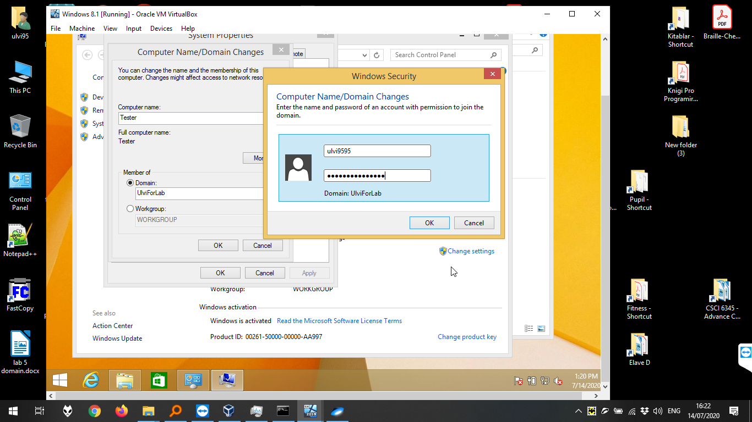

Success! After the restart, we can enter to the user in the domain:

